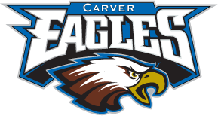
Carver Middle School
Back to School Supply List
2023-2024

All Grades 6th—8th
- Composition Notebooks
- Pencils
- Highlighters
- Loose Leaf Notebook Paper
- Earbuds
- Only clear bookbags and water bottles for those who choose to have one.

6th Grade Students
- Erasers
- Hand-held Pencil Sharpener

7th Grade Students
- 2 pocket folders with prongs
- Zipper pencil pouch
- Red pens

8th Grade Students
- Pens (any color)

